NEW EVO FACTORY MODELS
The Beta EVO Factory model means “replicas of the bikes used by Beta Factory riders in national and international competitions at the highest level.”
Beta Racing will be importing the 300, 250 and 200cc 2T machines in Factory versions. They will be available late April. Prices are 300cc $9900, 250/200cc $9600.
The most important technical changes are the 300cc version has a new engine, the 300cc version has a completely new rear shock and linkage system and the bikes are around 3kg lighter than the standard bikes.
The experience of the Factory team and the use of aftermarket parts have resulted in the creation of bikes with very high technical content, excellent riding dynamics and improved performance at the top level. The engine and frame have been developed to meet the new FIM non-stop regulations. The new non-stop rules demand a bike with smooth progressive power delivery from idle, low stall speed and smooth responsive power delivery as the revs build. These bikes are dedicated not only to expert riders who are looking for high performance but also hobby riders who want an exclusive trial motorcycle built with unique features.
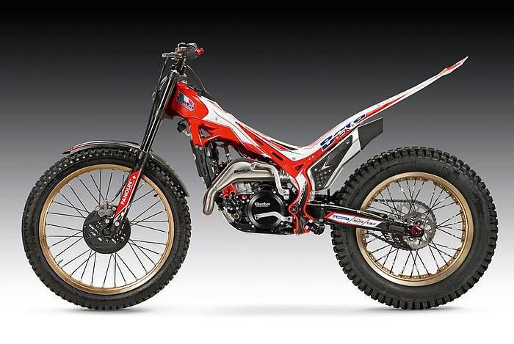
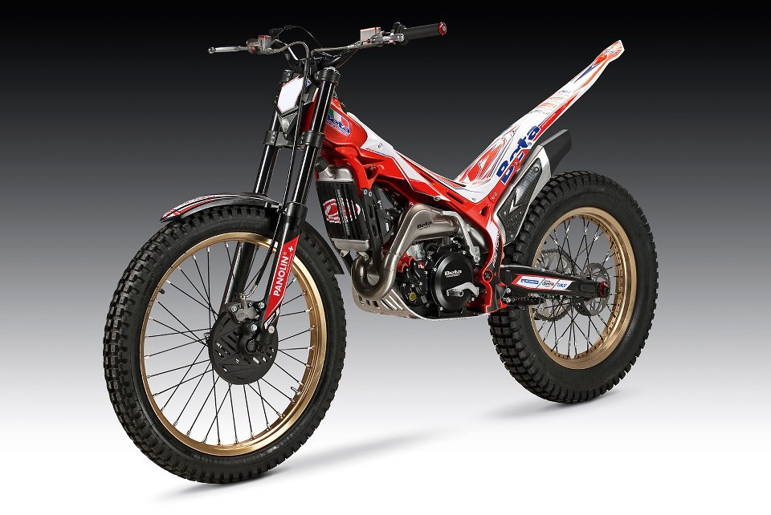Technical details 300cc 2T: ENGINE
- Magnesium crankcases give a weight saving of around 1.5kg.
- Clutch has new internal ratios for a better transfer of torque. Reduced preload on the clutch springs for a lighter clutch action and better control of the engagement point. Clutch discs have a different machining to ensure more accurate engagement with very stable performance.
- Intake and exhaust port timing modified to increase low down rpm torque.
- Larger diameter crank to increase inertia without increasing weight.
- Crankshaft connecting pin with increased diameter for greater rigidity and a reduction in vibration.
- Titanium exhaust with a new shape that provides smoother power delivery at low rpm, a more linear torque curve and an increase in performance at high rpm. Also the weight saving is around 500gms.
- New kick start ratio to reduce stress on the kick start lever.
- 10 – 42 final drive ratio to match the new clutch ratio.
- Black covers for cylinder head and side cover.
- Red silicone radiator hoses which provide better cooling.

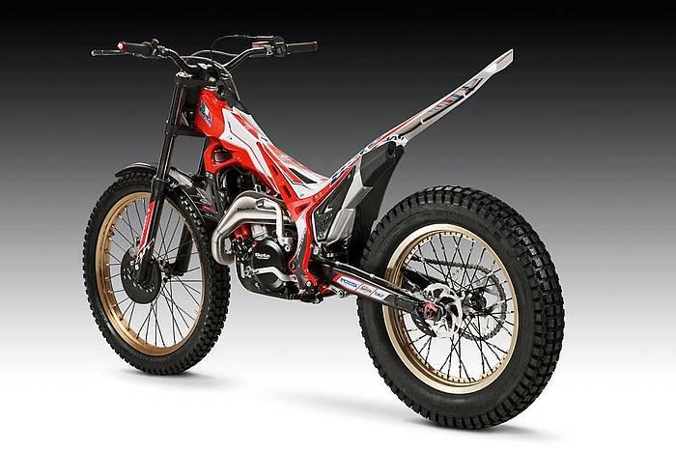
FRAME
- CNC machined triple clamps from billet aluminium with a black anodized finish. These reduce weight by around 500gms and provide eight different handlebar mounting positions.
- New front forks with SKF reduced friction front fork seals, new settings, lightened preload cap and lightened internal hydraulic cartridge. The rebound damping settings can now be adjusted using a knob.
- Completely new rear suspension linkage. The rear shock is completely new. It holds a larger volume of oil, greater length and modified piston geometry – exclusive to Betamotor. The rear suspension is soft and sensitive in the first part of its travel with increase damping at the end of its travel to prevent bottoming out. The new rear suspension offers increased stability, improved grip and better shock absorption.
- Factory wave discs for improved heat dissipation giving improved stability and performance.
- Michelin X-light tyres give a weight saving of around 500gms.
- Gold plated rims.
- Many parts in red anodized aluminium such as lever adjusters, master cylinder caps, oil filler caps, chain tension adjusters, handle bar end caps.
- Anodized billet aluminium foot pegs – lighter, stronger with a better level of grip than steel pegs.
- A new Factory graphics kit to replicate the official Beta team World Championship bikes.
Technical details 250cc and 200cc 2T: ENGINE
- Magnesium crankcases give a weight saving of around 1.5kg fitted to the 250cc engine. The 200cc Factory comes with the standard 200cc engine.
- Titanium exhaust with a new shape that provides smoother power delivery at low rpm, a more linear torque curve and an increase in performance at high rpm. Also the weight saving is around 500gms.
- Black covers for cylinder head and side cover.
- Red silicone radiator hoses which provide better cooling.
FRAME
- CNC machined triple clamps from billet aluminium with a black anodized finish. These reduce weight by around 500gms and provide eight different handlebar mounting positions.
- New front forks with SKF reduced friction front fork seals, new settings, lightened preload cap and lightened internal hydraulic cartridge. The rebound damping settings can now be adjusted using a knob.
- Factory wave discs for improved heat dissipation giving improved stability and performance.
- Michelin X-light tyres give a weight saving of around 500gms.
- Gold plated rims.
- Many parts in red anodized aluminium such as lever adjusters, master cylinder caps, oil filler caps, chain tension adjusters, handle bar end caps.
- Anodized billet aluminium foot pegs – lighter, stronger with a better level of grip than steel pegs.
- A new Factory graphics kit to replicate the official Beta team World Championship bikes.

